FIC Class Scheduler for Fraser International College
Requirements And Specification Document
2023 July 4
Version 1 (Proposal), Version 2 (Iteration 1), Version 3(Iteration 2),Version 4(Iteration 3)
Group 2
Brian Lee (301441123), Jeff Chiang (301451653), Joseph Lunderville (200014381), Peiman Zhiani A. (301438914) , Thomas Reginold George (301414337)

Abstract
The FIC Class Scheduler is a course schedule planning tool to help administrative staff develop class schedules which respect the preferences of the teaching staff and maximize their course offerings in the space available. This browser-based application’s primary feature is the generation of a class schedule for the school based on the courses offered, assigning the classes to rooms and professors according to suitability, availability, seniority, and preferences, followed by whatever other constraints are identified. In the proposed version, the application will focus on providing a clear workflow and generating efficient schedules; future work may include features such as tuning or manual tweaking of already-generated schedules, or direct integration of feedback from teachers.

Background

The Customer: Fraser International College
Fraser International College is a small learning institution located on the Simon Fraser University campus, supporting international students transitioning into degree programs at SFU.
The primary user of our web application will be the FIC administrative staff responsible for creating and managing course schedules. Alongside the admins, the professors at FIC will interact indirectly via a survey which records their availability and teaching preferences.

Core Problem And Solution
As a small school offering the full range of first year classes for multiple programs, FIC must draw on a pool of part-time teaching staff with very diverse qualifications to teach different classes. This presents a challenging scheduling problem for the administrative staff tasked with drawing up a schedule every semester. Matching staff to classes to rooms is already complex, and further complicating the schedule, part time teachers who are critical to filling out the pool of qualified candidates inevitably have commitments outside FIC.
At Fraser International College, the course and professors scheduling is currently a manual process, managed using spreadsheets. This process is tedious, prone to error, and time-consuming. Checking for double-booked rooms or classes with multiple teachers is not simple. There is an opportunity to automate both the schedule generation and the error-checking afterwards, resulting in better schedules made faster.

Competitive Analysis
There are a large number of hosted online systems which offer shift scheduling, such as findmyshift (https://www.findmyshift.com/ca/classroom-scheduling), deputy (https://www.deputy.com/industry/education), or Creatrix Campus (https://www.creatrixcampus.com/). Many of these offerings are derived from systems primarily targeting service-industry jobs, and as such focus on shorter-term dynamic scheduling, and features such as time tracking, overtime management, relief coverage for staff who are temporarily away, and so on. These are considerations not immediately relevant to the fixed schedule optimization problem FIC faces. Of course, even a system which is capable of solving FIC’s problems will still need to be configured correctly, and have unneeded features disabled or hidden (if that is possible). We will instead create a directly targeted solution which addresses FIC’s precise needs.

Project Planning

Actors
User: A Coordinator, Instructor, or IT Support with access to the FIC Class Scheduler.
Coordinator: An administrative staff member at FIC who supports Instructors by creating and updating schedules.
Instructor: A teaching staff member at FIC.
IT Support: A technical staff member at FIC responsible for the deployment and maintenance of the FIC Class Scheduler, and the roster of authorized Users.
System: The FIC Class Scheduler.

User Stories

Login

As a User, I log in to the System so that I can access the interface specific to my role.
The User is accessing the System for the first time this session. They access the website and are presented with the login page, and input their username and password.

Triggers/Preconditions:
- User would like to use one of the System features.
- User is not already logged in.

Actions/Postconditions:
- If credentials are accepted: User is redirected to a page according to the user’s role.
- If credentials are accepted: System features and internal pages are available according to the User’s role.
- If credentials are rejected: System features and internal pages are not available.

Acceptance Tests
- Successful login as Coordinator:
  - Clear browser cookies and other local data
  - Access the system main webpage via the public URL in a modern browser
  - Enter username “coordinator” and password “coordinator”
  - Click “Login”
  - Expect: browser should be redirected to the Coordinator landing page
- Successful login as Instructor:
  - Clear browser cookies and other local data
  - Access the system main webpage via the public URL in a modern browser
  - Enter username “instructor” and password “instructor”
  - Click “Login”
  - Expect: browser should be redirected to the Instructor landing page
- Successful login as IT Support:
  - Clear browser cookies and other local data
  - Access the system main webpage via the public URL in a modern browser
  - Enter username “admin” and password “admin”
  - Click “Login”
  - Expect: browser should be redirected to the IT Support landing page
- Failed login:
  - Access the system main webpage via the public URL in a modern browser
  - Enter (a) username “boogie” and password “coordinator”, or (b) username “coordinator” and password “boogie”
  - Click “Login”
  - Expect: error message indicating credentials are incorrect

Unit Tests
See UserRepositoryTests, UserControllerTests

Iteration
Implemented in iteration 1

Mockup
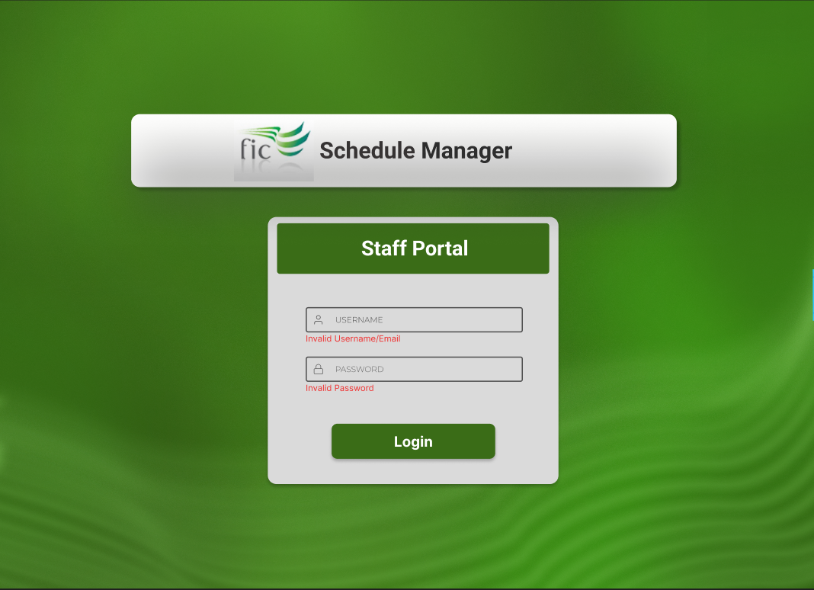

Logout

As a coordinator or instructor, I log out from the system to prevent unauthorized use of my account.
From any screen, the coordinator selects the “log out” link in the corner of the screen. Their browser is redirected to the login page or front page of the system and they are no longer able to access any of the system features until they log in again.

Triggers/Preconditions
- Coordinator is done using the system.

Actions/Postconditions
- Browser is redirected to the login page or front page.
- Any internal cached credentials are cleared.

Acceptance Tests
- Login (use Login: Successful Login as Coordinator test)
- Navigate to an internal page
- Copy the internal page address to the clipboard
- Select “Log Out” link
- Expect: System should now redirect browser to login page or front page
- Attempt to access an internal link by pasting the copied link to the URL bar
- Expect: System should present an authentication error or redirect to the login page

Unit Tests
See UserRepositoryTests, UserControllerTests

Iteration
Implemented in iteration 1

View Schedule

As an Instructor, I view the next semester’s course schedule, to check that it is acceptable to me and plan my semester
Immediately after login, the Instructor is shown their course schedule as their landing page. (Alternatively, they are logged in, and select the “Schedules” menu option.) They select the date dropdown in the course schedule page, and advance to the next semester. The next semester’s schedule is shown.

Triggers/Preconditions
- Coordinator is logged in.

Actions/Postconditions
- The Instructor’s schedule is shown.

Acceptance Tests
- Login (use Login: Successful Login as Instructor test)
- Expect: System shows “Schedules” landing page with the Instructor’s schedule.

Iteration
Overflow to iteration 3

Mockup
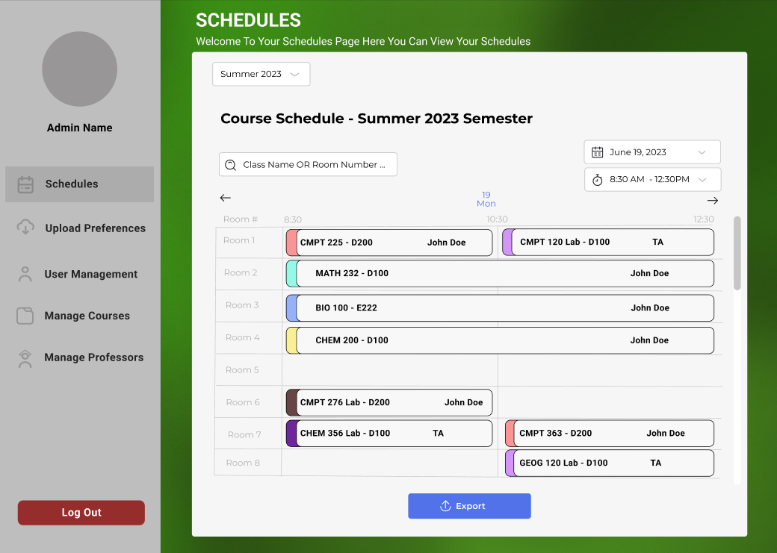

Add User

As IT Support, I add a User to the system to authorize their use.
From the IT Support landing page, IT Support selects the “User Management” menu option. The “User Management” page is shown. In this page, they select “Add User” and are shown a prompt to supply a username, password, and role. They fill out these prompts and select “Add User”. The new user is now visible in the user list on the “User Management” page, and the new user can log in using the entered credentials.

Triggers/Preconditions
- IT Support is logged in.

Actions/Postconditions
- If credentials are acceptable and the username is unique: The new User is able to log in using appropriate credentials.
- If credentials are not acceptable: an error is displayed describing the failure (bad characters in username, too short password, etc.)
- If the username is not unique: an error is displayed indicating the username is not unique.

Acceptance Tests
- Login: (use Login: Successful login as IT support)
- Upon adding a new user, fill out the form with username, password, and role, select the box to “Add User”
- Expect: new user to be visible in the user list on the “User Management” menu

Iteration
Implemented in Iteration 3

Remove User

As IT Support, I remove a User to the system to prevent unauthorized use.
From the IT Support landing page, IT Support selects the “User Management” menu option. The “User Management” page is shown. In this page, they select an existing user, and select “Remove User”. They are shown a confirmation dialog. They select “Yes, I want to remove this user”. The user is no longer visible in the user list on the “User Management” page, and the user cannot log in.

Triggers/Preconditions
- IT Support is logged in.

Actions/Postconditions
- If user is acceptable
- If the user selected is the IT Support user:

Acceptance Tests
- Successful Removal
- The IT Support logs in to the system using their credentials
- The system presents the IT Support with the main dashboard where the IT support can select an existing user, and select “Remove User”
- Expect: a confirmation dialog to confirm the deletion of the selected user

Iteration
Iteration 3

Add and Remove Instructors

As It supports, I can add and remove instructors into the system manually.
From the IT Support landing page, IT support selects “Instructors” from the debug menu. In this page they can add, remove instructors on the list of instructor in the database.

Triggers/Preconditions
- IT Support is logged in.

Actions/Postconditions
If adding instructor the id must be different from the existing instructor ids
If removing instructors the id must be filled out before pressing delete

Acceptance Tests
- Successful Removal
- The IT support logs in to the system using their credentials
- The system presents the IT Support with the main dashboard where they can access the debug menu to then select instructors.
- On Instructors they should see a list of already uploaded instructors and form they can fill out
- Find the desired instructor to remove and type its id into the form and press delete
- Expect: the instructor is no longer in the list.
- Successful Addition
- On instructors they see a form they can fill out
- Fill the form out with the proper fields and press create/update
- Expect: the instructor should now appear on the list

Iteration
Iteration 3

Add and Remove Classrooms

As It supports, I can add and remove classroom in the system manually.
From the IT Support landing page, IT support selects “Classrooms from the debug menu. In this page they can add, remove classrooms on the list of classrooms already in the database.

Triggers/Preconditions
- IT Support is logged in.

Actions/Postconditions
If adding classroom the id must be different from the existing classrooms ids
If removing classrooms the id must be filled out before pressing delete

Acceptance Tests
- Successful Removal
- The IT support logs in to the system using their credentials
- The system presents the IT Support with the main dashboard where they can access the debug menu to then select classrooms.
- On Instructors they should see a list of already uploaded classrooms and form they can fill out
- Find the desired classroom to remove and type its id into the form and press delete
- Expect: the classroom is no longer in the list.
- Successful Addition
- On classroom they see a form they can fill out
- Fill the form out with the proper fields and press create/update
- Expect: the classroom should now appear on the list

Iteration
Iteration 3

Add and Remove Semester Plans

As It supports, I can add and remove semester plans in the system manually.
From the IT support landing page, IT support selects “Semester Plans” from the debug menu. In this page they can inquire the data thats populated the semester plan already from the database.

Triggers/Preconditions
- IT Support is logged in.

Actions/Postconditions
- Semester plan must exist

Acceptance Tests
- Successful Removal
  - The IT support logs in to the system using their credentials
  - The system presents the IT Support main dashboard where they can access the debug menu to then select semester plans
  - They should see a already generated semester plan that already exists
  - Find the desired semester plan to remove and type its ID into the form and delete
  - Expect: the semester plan to no longer be in the list
- Successful Addition
  - All fields must be pre uploaded for a creation of a new semester plan (courses, instructors, classrooms)
  - Fill the form out and press create/delete
  - Expect: New semester plan be created

Add and Remove Block Splits

As IT supports, I can add and remove block splits in the system manually.
From the IT support landing page, IT support selects “Block Splits” from the debug menu. In this page they can inquire the data thats populated the semester plan already from the database.

Triggers/Preconditions
- IT Support is logged in.

Actions/Postconditions
- Block Splits must exist

Acceptance Tests
- Successful Removal
  - The IT support logs in to the system using their credentials
  - The system presents the IT Support main dashboard where they can access the debug menu to then select block splits
  - They should see a already block splits plan that already exists
  - Find the desired block split to remove and type its ID into the form and delete
  - Expect: the block split to no longer be in the list
- Successful Addition
  - All fields must be pre uploaded for a creation of a new block split (names, blocks)
  - Fill the form out and press create/delete
  - Expect: New block split to be created

Remove Schedule

As It supports, I can add and remove classroom in the system manually.
From the IT Support landing page, IT support selects “Schedule” from the debug menu. In this page they can remove a already generated schedule.

Triggers/Preconditions
- IT Support is logged in.

Actions/Postconditions
A schedule has already been generated

Acceptance Tests
- Successful Removal
- The IT support logs in to the system using their credentials
- The system presents the IT Support with the main dashboard where they can access the debug menu to then select schedules.
- On Instructors they should see the already generated schedule with an id
- Enter the desired id in the form and press delete
- Expect: the schedule to not be there anymore.

Iteration
Iteration 3

Coordinator Survey - Instructor Availability Survey Upload

As a Coordinator, I upload and view instructor responses from the survey system to prepopulate the availability data for a semester.

Triggers/Preconditions:
- The coordinator must provide a filled out .csv/.xlsx survey of the availability of instructors
- The coordinator has “logged in” to the system
- The coordinator has accessed the upload preferences page

Action/Postconditions:
- The System validates and processes the survey response data.
- For each instructor with available survey responses, the System pre-populates the instructor's availability data for the semester in the Scheduler System.
- If an instructor's availability data already exists for the semester, the System updates the existing data based on the imported survey responses.

Acceptance Tests:
- Successful import:
  - The Coordinator logs in to the Scheduler System using their credentials.
  - The System presents the Coordinator with the main dashboard, where the user can navigate to Upload All Preferences
  - The Coordinator selects a .csv/.xlsx file and initiates the import process.
  - The Coordinator checks the preferences based on the generated table to see if the imported file is the desired one
  - The Coordinator initiates the upload process by pressing upload file
  - Expect: Once the import is complete, the System provides a confirmation message to the Coordinator.

Iteration
Implemented in Iteration 2

3 Story Points

Mock Up sketch
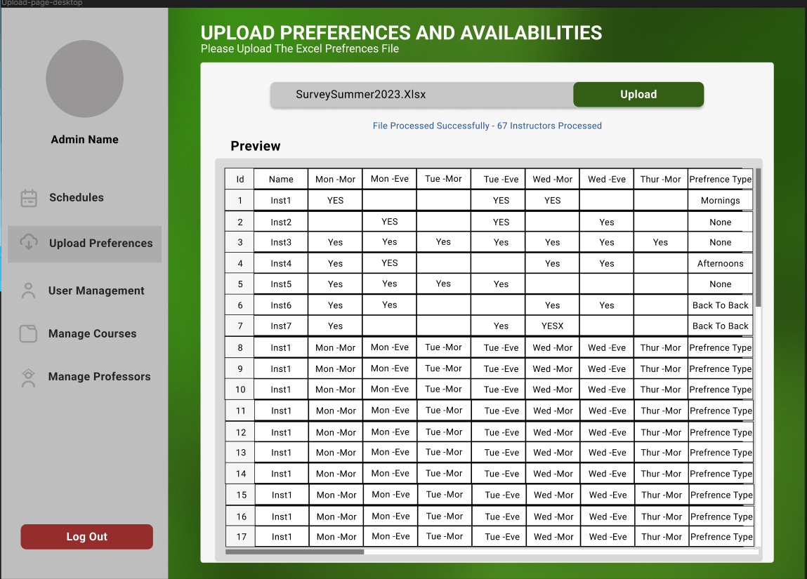

Coordinator Survey - Upload Facility Types and Constraints

As a Coordinator, I upload the data of all available types of facilities

Triggers/Preconditions
- The coordinator has the up-to-date information about available facilities
- The coordinator has “logged in” to the system and has necessary permissions to upload facility data.
- The coordinator has accessed the Configuration Page.

Action/Postconditions
- The System validates and processes the survey response data.
- If a facilities type data already exists for the semester, the System updates the existing data based on the imported survey responses.

Acceptance Tests
- Successful Import
  - The Coordinator logs in to the Scheduler System using their credentials.
  - The System presents the Coordinator with the main dashboard, where the user can navigate to Configuration Page
  - The Coordinator selects a .csv/.xlsx file for facility availability and initiates the import process.
  - The Coordinator checks the preferences based on the generated table to see if the imported file is the desired one
  - The Coordinator initiates the upload process by pressing upload file
  - Expect: Once the import is complete, the System provides a confirmation message to the Coordinator.

Iteration
Implemented in Iteration 2
Deleted in Iteration 3

3 Story Points

Coordinator Survey - Course Offering Constraint Upload

As a Coordinator, I upload and preview the constraint for the courses offered in the next semester to ensure the accuracy of the generated schedule

Triggers/Preconditions
- The next semester’s course offerings have been finalized and need to be added to the Scheduler.
- The coordinator has “logged in” to the system and has the necessary permissions to upload course information.
- The coordinator has accessed the Configuration Page.

Action/Postconditions
- The System validates and processes the constraint response data.
- For each course it populates the conflicts, course number, accreditation, facilities required and block type.
- If the course’s data already exist the system updates the existing data based on the imported constraints

Acceptance Tests
- Successful Import
  - The Coordinator logs in to the Scheduler System using their credentials.
  - The System presents the Coordinator with the main dashboard, where the user can navigate to Configuration
  - The Coordinator selects a .csv/.xlsx file and initiates the import process.
  - The Coordinator checks the constraints and courses offered based on the generated table to see if the imported file is the desired one
  - The Coordinator initiates the upload process by pressing upload file
  - Expect: Once the import is complete, the System provides a confirmation message to the Coordinator.

Iteration
Implemented in Iteration 2
3 Story Points

Coordinator View - View the Already Uploaded Course Offering Data
As a Coordinator, I can see the already uploaded course offering data

Triggers/Preconditions
- The coordinator has successfully uploaded Course Offering constraints
- The coordinator has “logged in” to the system and has necessary permissions to upload course offering data.
- The coordinator has accessed to manage course page

Action/Postconditions
- The System validates the uploaded data
- The Survey then shows a table of the already uploaded data.

Acceptance Tests
- Successful View
  - The Coordinator logs in to the Scheduler System using their credentials.
  - The System presents the Coordinator with the main dashboard, where the user can navigate to Course Page
  - The Coordinator press show current course offering list
  - Expect: A table to show what has been uploaded already

Iteration
Implemented in Iteration 3

3 Story Points

Coordinator Survey - Upload available classroom information with their respective Facilities as a Coordinator.

As a Coordinator, I upload the available classrooms with their room numbers and associated facilities in the Scheduler. This will help in scheduling classes and assigning appropriate locations for each class.

Triggers/Preconditions
- The coordinator has the list of available classrooms and its respective facilities.
- The coordinator has “logged in” to the system and has necessary permissions to upload classroom data.
- The coordinator has accessed the Configuration Page.

Action/Postconditions
- The System validates and processes the survey response data.
- The Survey then populates the available Classrooms with their room numbers and facilities.

Acceptance Tests
- Successful Import
  - The Coordinator logs in to the Scheduler System using their credentials.
  - The System presents the Coordinator with the main dashboard, where the user can navigate to Configuration Page
  - The Coordinator selects a .csv/.xlsx file and initiates the import process.
  - The Coordinator checks the preferences based on the generated table to see if the imported file is the desired one
  - The Coordinator initiates the upload process by pressing upload file
  - Expect: Once the import is complete, the System provides a confirmation message to the Coordinator.

Iteration
Implemented in Iteration 2
3 Story Points

Coordinator Survey - Upload available Instructors with their availability as a coordinator.
As a Coordinator, I upload the data of all available instructors along with their availability for each day of the week and parts of the day such as Morning, Afternoon and/or Evening into the Scheduler. This will help efficiently schedule classes and assign instructors based on their availability.

Triggers/Preconditions
- The coordinator has the up-to-date information about available instructors and their daily availability.
- The coordinator has “logged in” to the system and has necessary permissions to upload classroom data.
- The coordinator has accessed the Configuration Page.

Action/Postconditions
- The System validates and processes the survey response data.
- The Survey then populates the available instructors with their respective daily availability.

Acceptance Tests
- Successful Import
  - The Coordinator logs in to the Scheduler System using their credentials.
  - The System presents the Coordinator with the main dashboard, where the user can navigate to Configuration Page
  - The Coordinator selects a .csv/.xlsx file for instructor availability and initiates the import process.
  - The Coordinator checks the preferences based on the generated table to see if the imported file is the desired one
  - The Coordinator initiates the upload process by pressing upload file
  - Expect: Once the import is complete, the System provides a confirmation message to the Coordinator.

Iteration
Implemented in Iteration 2

3 Story Points

Coordinator View - View the Already Uploaded Instructor Availability and Instructor List
As a Coordinator, I can see the already uploaded instructor availability data

Triggers/Preconditions
- The coordinator has successfully uploaded instructor availability
- The coordinator has “logged in” to the system and has necessary permissions to upload instructor availability data.
- The coordinator has accessed to manage instructor page

Action/Postconditions
- The System validates the uploaded data
- The Survey then shows a table of the already uploaded data.

Acceptance Tests
- Successful View
  - The Coordinator logs in to the Scheduler System using their credentials.
  - The System presents the Coordinator with the main dashboard, where the user can navigate to Instructor Page
  - The Coordinator press show current instructor availability list and show current instructor list
  - Expect: A table to show what has been uploaded already

Iteration
Implemented in Iteration 3

3 Story Points

Generate Schedule

As a Coordinator, I generate a course schedule for the next semester to help plan and optimize instruction

Triggers/Preconditions
- All semester configuration and instructor availability information must be input into the system
- The coordinator has “logged in” to the system
- The coordinator has accessed the schedule generation page

Action/Postconditions
- A valid schedule is generated, based on the semester configuration entered into the system

Acceptance Tests
- Successful schedule generation:
  - The Coordinator logs in to the Scheduler System using their credentials.
  - The Coordinator prepares a valid semester configuration as desired, including classrooms, course offerings instructor availability.
  - The Coordinator navigates to View Full Schedule
  - The Coordinator activates the “Generate Schedule” button in the interface to initiate schedule generation
  - The system shows loading text as it prepares the generated schedule.
  - Expect: the system shows a valid schedule

Unit Tests
See ScheduleControllerTests

Iteration
Implemented in Iteration 3

5 Story Points

View and Download Schedule

As a Coordinator, I view the next semester’s course schedule, to validate that it has been generated correctly or identify conflicts and issues

Triggers/Preconditions
- The coordinator has “logged in” to the system
- There is a generated semester view with a download table button

Action/Postconditions
- The system displays the last generated schedule, including room and instructor assignments for every course offered,
- A downloaded csv file of the generated schedule

Acceptance Tests
- The Coordinator logs in to the Scheduler System using their credentials.
- The System presents the Coordinator with the main dashboard, where the user can navigate to View Full Schedule
- Expect: the system displays the last generated schedule, with a button that says Dowload Table
- The Coordinator press the button
- Expects: A csv file of the generated schedule will now start downloading

Unit Tests
See ScheduleControllerTests

Iteration
Implemented in Iteration 3

3 Story Points

Automated Testing

Backend Tests

UserRepositoryTests
- This class is JUnit test class responsible for testing the UserRepository.
- A mock user is created by setting the username to “testUsername” and password to “testPassword”.
- The user is saved to userRepository.
- Assert Tests are done to make sure the username and password for the retrieved user is the same for the user that was created.

UserControllerTests

Test to Verify login endpoint behavior with a non-existing user.
- Create a mock ApplicationUser object
- A login is performed with data for a non-existing username
- Login attempt with non-existing username failing is the expected result.

Test to verify the login endpoint’s successful behavior with an existing user having the ADMIN role
- Create a mock ApplicationUser object for an existing admin user with a known username and password, assigned the ADMIN role.
- Perform a request to login endpoint with data for an existing username and correct password.
- Expect HTTP status 200 indicating successful login.
- Expect the username field to have the value “testUsername”.
- Expect the roles field response to have the value “ADMIN” for the Admin role
- A valid JWT token should be issued.

Test to verify the login endpoint’s successful behavior with an existing user having the COORDINATOR role
- Create a mock ApplicationUser object for an existing coordinator user with a known username and password, assigned the COORDINATOR role.
- Perform a request to login endpoint with data for an existing username and correct password.
- Expect HTTP status 200 indicating successful login.
- Expect the username field to have the value “testUsername”.
- Expect the roles field response to have the value “COORDINATOR” for the coordinator role
- A valid JWT token should be issued.

Test to verify the login endpoint’s successful behavior with an existing user having the INSTRUCTOR role
- Create a mock ApplicationUser object for an existing instructor user with a known username and password, assigned the INSTRUCTOR role.
- Perform a request to login endpoint with data for an existing username and correct password.
- Expect HTTP status 200 indicating successful login.
- Expect the username field to have the value “testUsername”.
- Expect the roles field response to have the value “INSTRUCTOR” for the Instructor role
- A valid JWT token should be issued.

ScheduleControllerTests

Test to verify the behavior of the Get Latest Schedule endpoint
- Create a mock user for authentication with the role “ADMIN”, a mock schedule for Fall 2023 semester and create a mock plan for Fall 2023.
- Mock the data returned by classScheduleRepository.findALL() method to return a list containing the mock schedule
- Expect an HTTP status code of 200 indicating a successful request.
- Expect the response to have the “semester” field with the value of the mock schedule’s semester
- Print the output of the request.
- The Get Latest Schedule endpoint should return the schedule for the “FALL 2023” semester.

Test to verify the behavior of the Get Schedule by ID endpoint
- Create a mock user for authentication with the role “ADMIN”, a mock schedule for Fall 2023 semester and create a mock plan for Fall 2023.
- Mock the data returned by classScheduleRepository.findALL() method to return a mock schedule when provided with the ScheduleID
- Perform a GET request to the "/api/schedules/{id}" endpoint, where the {id} placeholder is replaced with the schedule ID (1). Include the mock user for authentication
- Expect an HTTP status code of 200 indicating a successful request.
- Expect the response to have the “semester” field with the value of the mock schedule’s semester
- Print the output of the request.

Test to Verify the behavior of the "Get Schedules by Query" endpoint.
- Create a mock user for authentication with the role “ADMIN”, a mock schedule for Fall 2023 semester and create a mock plan for Fall 2023.
- Mock the data returned by the classScheduleRepository.findBySemester method to return a HashSet containing the mock schedule when provided with the semester "Fall 2023".
- Perform a GET request to the "/api/schedules" endpoint, including the query parameter "semester" with the value "Fall 2023".
- Expect an HTTP status code of 200 indicating a successful request.
- Expect the response to have the “semester” field with the value of the mock schedule’s semester
- Print the output of the request
- The "Get Schedules by Query" endpoint should return the schedule(s) for the "Fall 2023" semester.

Test to Verify the behavior of the "Generate Schedule" endpoint.
- Create a mock user for authentication with the role “ADMIN”, a mock schedule for Fall 2023 semester and create a mock plan for Fall 2023.
- Mock the data returned by the semesterPlanRepository.findById method to return the mock semester plan when provided with the plan ID (1).
- Perform a POST request to the "/api/generate" endpoint with data containing the "semesterPlanId" field with the value 1 (mockPlan's ID).
- Expect an HTTP status code of 200 indicating a successful request.
- Expect the response to have the “semester” field with the value of the mock schedule’s semester
- Print the output of the request
- The "Generate Schedule" endpoint should successfully generate a schedule based on the provided semester plan.

BlockSplitControllerTest
Test to verify the behavior of “readListByQuery” endpoint
- The test starts by mocking the data returned by the repository. A list of mock BlockRequrementSplit is created.
- blockRequirementSplitRepositor.findAll() method is setup to return the mock data when called
- The test then performs a GET request to "/api/block-splits" endpoint
- It then verifies the response of the request to ensure that it meets the expectations.
- Expect an HTTP status code of 200 indicating a successful request.
- Check the expected value to the values of the mockBlockSplits list
- Verify that blockRequirementSplitRepository.findAll() method was called once
- And lastly verify that no more interactions occurred with blockRequirementSplitRepository.
Test to verify the behavior of “readListByQuery” endpoint in an exception case
- The test starts by preparing a mock scenario where the blockRequirementSplitRepository is configured to throw a RuntimeException when the findAll() method is called.
- The test then performs a GET request to "/api/block-splits" endpoint
- It then verifies the response of the request to ensure that it meets the expectations.
- Expect an HTTP status code of 400 indicating a Bad Request indicating that an exception occurred during the data retrieval process.
- Verify that blockRequirementSplitRepository.findAll() method was called once
- And lastly verify that no more interactions occurred with blockRequirementSplitRepository.
Test to verify the behavior of “readOneById” endpoint
- The test starts by preparing a mock BlockRequirementSplit object representing the data that would be returned by the repository for the given ID.
- blockRequirementSplitRepositor.findById(1) method is mocked to return the mock data when called with ID 1
- The test then performs a GET request to "/api/block-splits/{id}" endpoint
- It then verifies the response of the request to ensure that it meets the expectations.
- Expect an HTTP status code of 200 indicating a successful request.
- Check the expected value to the values of the mockBlockSplit
- Verify that blockRequirementSplitRepository.findById() method was called once with the ID 1
- Verify that no more interactions occurred with blockRequirementSplitRepository after retrieving the data for the given ID.
Test to verify the behavior of “readOneById” endpoint in an exception case
- The test starts by preparing a mock scenario where the blockRequirementSplitRepository is configured to throw a RuntimeException when the findById() method is called with blockSplitId set to 1.
- The test then performs a GET request to "/api/block-splits/{id}" endpoint
- It then verifies the response of the request to ensure that it meets the expectations.
- Expect an HTTP status code of 400 indicating a Bad Request indicating that an exception occurred when the data is not found.
- Verify that blockRequirementSplitRepository.findById() method was called once with the blockSplitId.
- Verify that no more interactions occurred with blockRequirementSplitRepository.
Test to verify the behavior of “createOrUpdateList” endpoint
- The test prepares a list of mock BlockRequirementSplitDto objects that will be sent in the request body of the API
- It also prepares mock BlockRequirementSplit objects that represent the data saved in the repository after processing the request.
- blockRequirementSplitRepository.save method is mocked to return these objects
- The test then performs a POST request to "/api/block-splits" endpoint
- It then verifies the response of the request to ensure that it meets the expectations.
- Expect an HTTP status code of 200 indicating a successful request.
- Check the expected values
- Verify that blockRequirementSplitRepository.save() method was called twice.
- Verify that no more interactions occurred with blockRequirementSplitRepository after retrieving the data for the given ID.
Test to verify the behavior of “createOrUpdateList” endpoint in an exception case with Null Values
- The test prepares a list of mock BlockRequirementSplitDto objects with null values for required field that will be sent in the request body of the API
- The test then performs a POST request to "/api/block-splits" endpoint
- Expect an HTTP status code of 400 indicating a bad request.
- Verify that blockRequirementSplitRepository.save() method was not called.
Test to verify the behavior of “createOrUpdateList” endpoint in an exception case
- The test prepares a list of mock BlockRequirementSplitDto objects that will be sent in the request body of the API
- blockRequirementSplitRepository.save method is mocked to throw a RuntimeException when called.
- The test then performs a POST request to "/api/block-splits" endpoint
- Expect an HTTP status code of 400 indicating a bad request.
- Verify that blockRequirementSplitRepository.save() method was called only once before the exception was thrown.
Test to verify the behavior of “updateOneById” endpoint
- The test prepares a list of mock BlockRequirementSplitDto object representing the updated data that will be sent in the request body of the API
- The blockRequirementSplitRepository.findById(1) method is mocked to return an Optional containing the existing BlockRequirementSplit object.
- blockRequirementSplitRepository.save method is mocked to return a BlockRequirementSplit object after saving the updated data.
- The test then performs a PUT request to "/api/block-splits/{id}" endpoint of the API
- It then verifies the response of the request to ensure that it meets the expectations.
- Expect an HTTP status code of 200 indicating a successful request.
- Check the expected values.
- Verify that blockRequirementSplitRepository.save() method was called once during the test execution.
- Verify that no more interactions occurred with blockRequirementSplitRepository after retrieving the data for the given ID.
- The test then verifies the updated block split data (capturedBlockSplit).
Test to verify the behavior of “updateOneById” endpoint in an exception case
- The test initializes an int variable blockSplitId with value 1and prepares a BlockRequirementSplitDto object with an ID of 2.
- The test then performs a PUT request to "/api/block-splits" endpoint with blockRequirementSplitDto include as the request body in JSON format while the ID in the request URL is set to blockSplitId(1).
- Expect an HTTP status code of 400 indicating a bad request due to the mismatched IDs.
- Verify that blockRequirementSplitRepository.findById() method was not called.
- The test also ensures that there are no other interactions with the blockRequirementSplitRepository.
Test to verify the behavior of “deleteOneById” endpoint
- The test initializes an int variable blockSplitId with value 1 representing the ID of the block split to be deleted from the repository.
- The test then performs a DELETE request to "/api/block-splits/{id}" endpoint.
- The request includes the blockSplitID in the request URL to specify the ID of the block split to be deleted
- It then verifies the response of the request to ensure that it meets the expectations.
- Expect an HTTP status code of 200 indicating a successful request.
- Verify that blockRequirementSplitRepository.deleteByID() method was called once with the blockSplitId.
- Verify that no more interactions occurred with blockRequirementSplitRepository after the delete operations.
Test to verify the behavior of “deleteOneById” endpoint in an exception case
- The test initializes an int variable blockSplitId with value 1 representing the ID of the block split to be deleted from the repository.
- The blockRequirementSplitRepository.deleteById method is mocked to throw an IllegalArgumentException when called to simulate an exception scenario when attempting to delete data from the repository
- The test then performs a DELETE request to "/api/block-splits/{id}" endpoint.
- The request includes the blockSplitID in the request URL to specify the ID of the block split to be deleted
- Expect an HTTP status code of 400 indicating a bad request due to the exception from the Repository.
- Verify that blockRequirementSplitRepository.deleteByID() method was called once during the test execution;
- The test also ensures that there are no other interactions with the blockRequirementSplitRepository.
The test approach for each endpoint in other controllers follows a similar pattern of data mocking, request execution, response verification and interaction validation. For each endpoint, mock data is prepared to simulate different scenarios, and the repository methods are mocked accordingly to return expected data or throw exceptions. The responses are also verified against expected outcomes such as specific HTTP status codes or response body content. Finally the interactions with the repository are verified to ensure the correct handling of data operations. This testing methodology ensures thorough evaluation and validation of the behavior and functionally of all the endpoints in other controllers.

Changes And Improvements

Security
The login page has undergone significant improvements to enhance its functionality and user experience. One notable improvement is the shift of managing tokens on the client side to linking them to a backend system. This transition ensures more conventional and secure token management. Now, when the user logs in with their credentials, the backend generates a JWR (JSON Web Tokens) specifically tailored to their roles as either an “Instructor” or a “Coordinator”. These JWTokens serve as digital authentication tokens and provide seamless authorization to access relevant features and functionality based on their respective roles.

Server Side Infrastructure
Attached to the zip you will find 2 videos ( video 1 followed by video 2); displaying the setup of the backend features, controllers, Data objects, and repositories set up for different tables imported. Tables such as : Facilities, Classrooms, instructor Accreditations, Instructors, Courses and Instructor availability and setup proper working endpoint for each, with error checking and returning custom status ( 200 created, 201, 500 server error, 409 conflicted if already exist)

Client
In addition, the client interface has been refined to give the user a more fluid login and logout process. Upon successful authentication, users are granted with a main page based on their designated roles as “Instructors” or “Coordinators”. This role based access controls ensures that individuals are only able to interact and view the features relevant to their assigned responsibility. Additionally, the logout feature has been optimized for a more fluid process. Users can now log out of the system ensuring a seamless transition.

User Uploads
User upload has been changed to where they only have to upload instructor availability, course offerings and classrooms. Due to this change the parsing and uploading had to be redone and changed to fit the new format. Users now don’t need to upload as many csv/xlsx files.

Schedule Generation
The system is now capable of generating simple schedules adhering to the constraints embodied by the uploads as they currently are implemented, including a mix of half and full periods, courses which are scheduled to multiple periods, courses which have a mix of room type requirements, instructor approval to teach specific courses, etc. Custom instructor preferences and linear optimization which would take into account soft preferences are not yet implemented, but are straightforwardly implementable within the existing framework given further development time.

Team Velocity

Iteration 1
Not measured

Iteration 2
15 points total

Completed Stories
3 points | Coordinator Survey - Instructor Availability Survey Upload
3 points | Coordinator Survey - Upload Facility Types and Constraints
3 points | Coordinator Survey - Course Offering Constraint Upload
3 points | Coordinator Survey - Upload available classroom information with their respective Facilities as a Coordinator
3 points | Coordinator Survey - Upload available Instructors with their availability as a coordinator

Iteration 3
40 Points total

Complete Stories
3 points | Add Users and Remove Users
5 points | Add and Remove Instructors
5 points | Add and Remove Semester Plan
5 points | Add and Remove Classrooms
5 points | Add and Remove Block Splits
2 points | View Already Uploaded Instructor Availability and Instructor
2 points | View the Already Uploaded Course Offering
2 points | View the Already Uploaded Classrooms
8 points | Generate Schedule based on Uploaded Constraints
3 points | View and Download Generated Schedule

This iteration showed dramatically higher velocity for a number of reasons:
- Some more complex, long-running work which had been started in iteration 2 was finished this iteration. Since story points are counted in the interaction where the user-facing feature is actually delivered, this inevitably creates a delay which is not totally reflective of the amount of effort put in. In particular, most of the preparatory work for the oversize Generate Schedule story, including data design, model implementation, and investigation of tools, could not be counted to the iterations it was done in.
- The team became more familiar with the tools and frameworks in use, and team dynamics stabilized. This led to a significant increase in work efficiency.
- The team did put in more effort as a whole to deliver the most important features, knowing that this was the last chance. This had a significant though not overwhelming effect.

Extra sketches for mockups:

Product Backlog

Epic: Edit And Update Schedule
- Edit Schedule: As a Coordinator, I manually make modifications to the generated schedule to resolve issues the automatic scheduler didn’t handle well, or alter the schedule in response to availability or course offering changes
- Request Schedule Change: As an Instructor, I request modifications to the Coordinator for my schedule
Future work might also include features like:
- The ability to optimize the schedule for soft preferences
  - Preferring particular instructors for specific courses
  - Preferring daytime or nighttime for particular courses without a strict mandate
  - Instructors’ preference to work more or fewer shifts per day
  - Instructors’ preference to work consecutive shifts or consecutive days
- Accommodation of co-requisites, courses which should must be scheduled into different blocks, so that students will be able to register for both in the same semester
- Better feedback about why a schedule is impossible to generate
- Better error feedback and robustness generally

